- List the types of ANN and discuss any 2 ANNs.
- Write the perceptron algorithm of ANN.
- Define Activation function and describe any 5 activation functions.
- With the help of Neat diagram, explain the perceptron model.
- With the help of neat diagram, Explain McCilloch and Pills Neuron.
- Apply Naïve bayes algorithm for the following dataset.
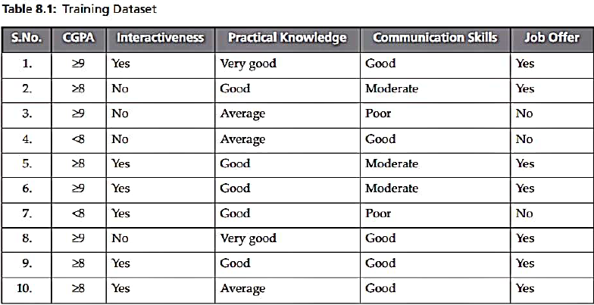
- Discuss the proximity measures in clustering algorithm.

- Apply single linkage algorithm. 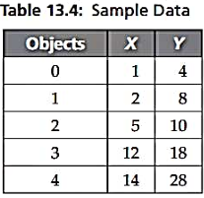
- Write the mean-shift clustering algorithm.
- Apply partitional clustering algorithm for the following data set
- What are the basic components of Reinforcement learning.
- Design a perceptron to perform the Boolean function AND and update the weightsuntil Boolean function gives the desired output. Intitial weights w₁ = 0.3, w₂= -0.2, learning rate ∞= 0.2 and bias θ= 0.4. .
- Apply K-Means clustering method for the following data set.
Objects | X-Coordinates | Y-Coordinates
1 | 2 | 4
2 | 4 | 6
3 | 6 | 8
4 | 10 | 4
5 | 12 | 4

- What are the advantages of ANN.
- What are the limitations of ANN.
- What are the challenges of ANN.
- What are the Applications of ANN.
- Apply bayes optimal classifier for the following dataset.
- Define the following: Prior probability, Posterior probability and likelihood probability.
- Define Maximum A Postirior (MAP) hypothesis and Maximum likelihood hypothesis.
- List the advantages and disadvantages of Clustering.
- List the applications of Clustering
- Differentiate between Classification and Clustering.
- List the advantages and disadvantages of Mean-shift clustering algorithm.
- List the characteristics of Reinforcement learning.
- List the Challenges of Reinforcement learning.
- List the Applications of Reinforcement learning.
- Differentiate between RL and Supervised learning.
- Differentiate between RL and Unsupervised learning
- Apply Bayes optimal classifier for the following data set to diagnose the patient with Covid Positive/Negative.
